**Experiment-9**

Create a simple cloud software application for Hospital information system for SIMATS Hospital using any Cloud Service Provider to demonstrate SaaS with fields of patient name, age, address, phone, email, Attender name, attender phone, doctor name, diseases, etc.

**Implementation:**

**STEP 01:**

Open a Zoho web application and click a Create a New application and Create a New Component And select a Component Type as Form Type.

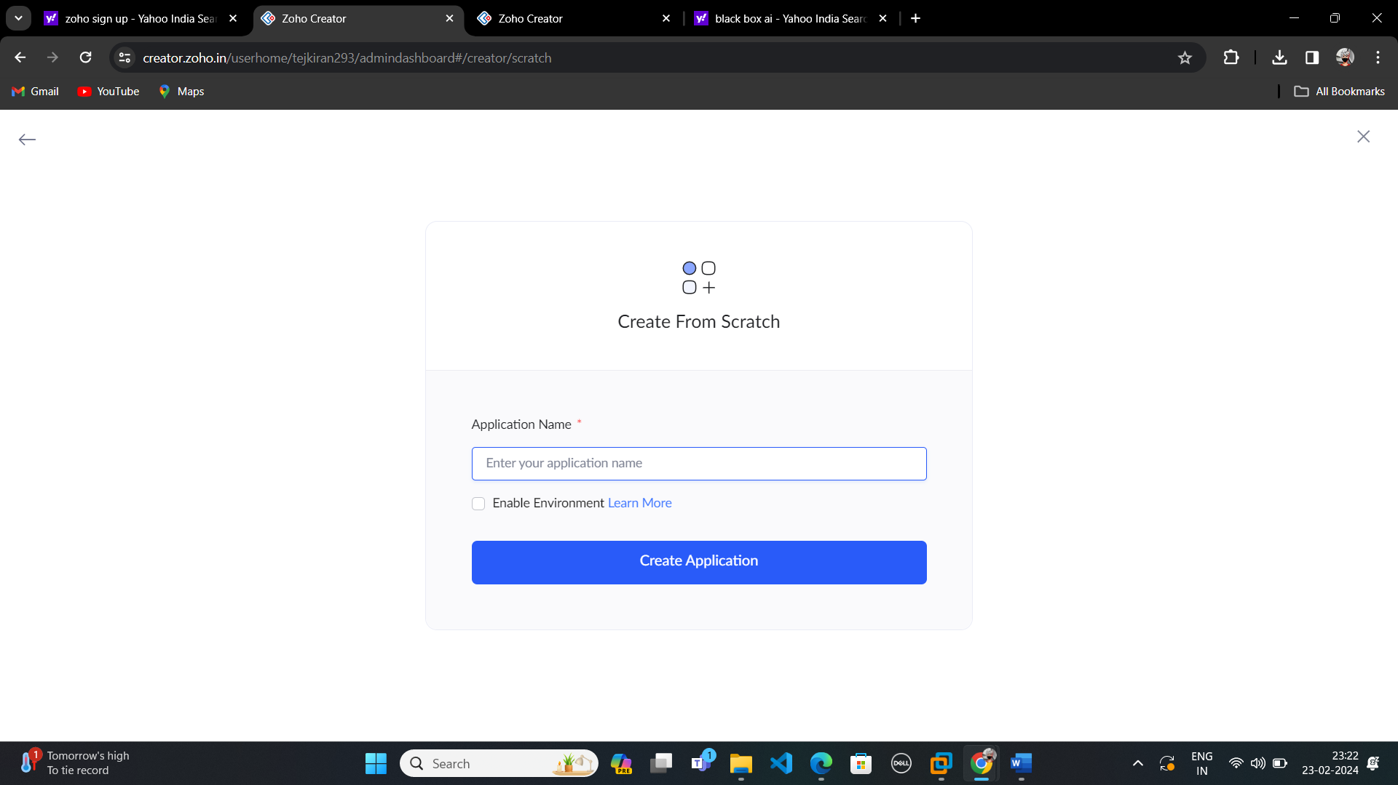

**STEP:02**

Start To a Create a Form from Scratch

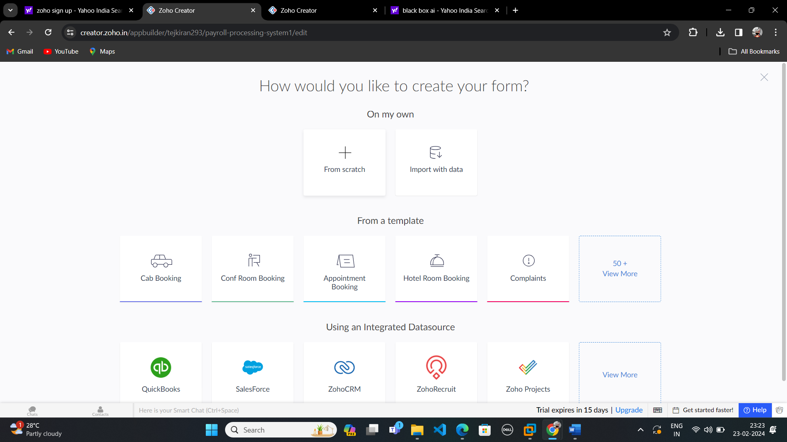

**STEP 03:**

To Give a Name For Your Form and click a Button Create From Scratch

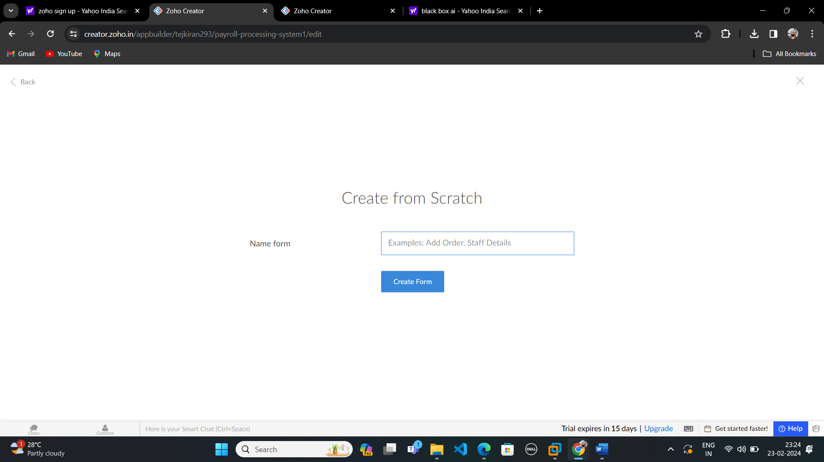

**Step-04:**

Create Log in form and edit the form.

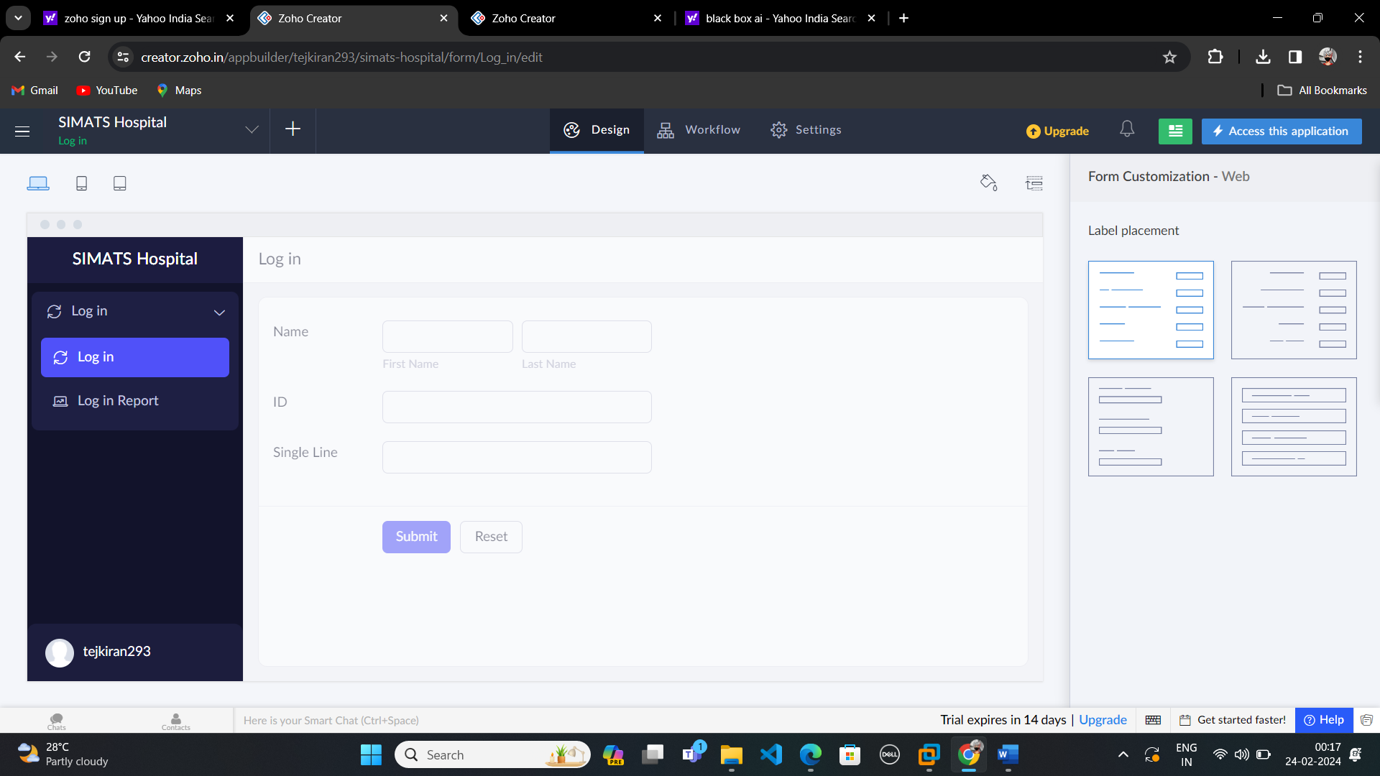

**Step-05:**

After Finishing that,Create another form for your application by clicking a Add icon and Edit that form.

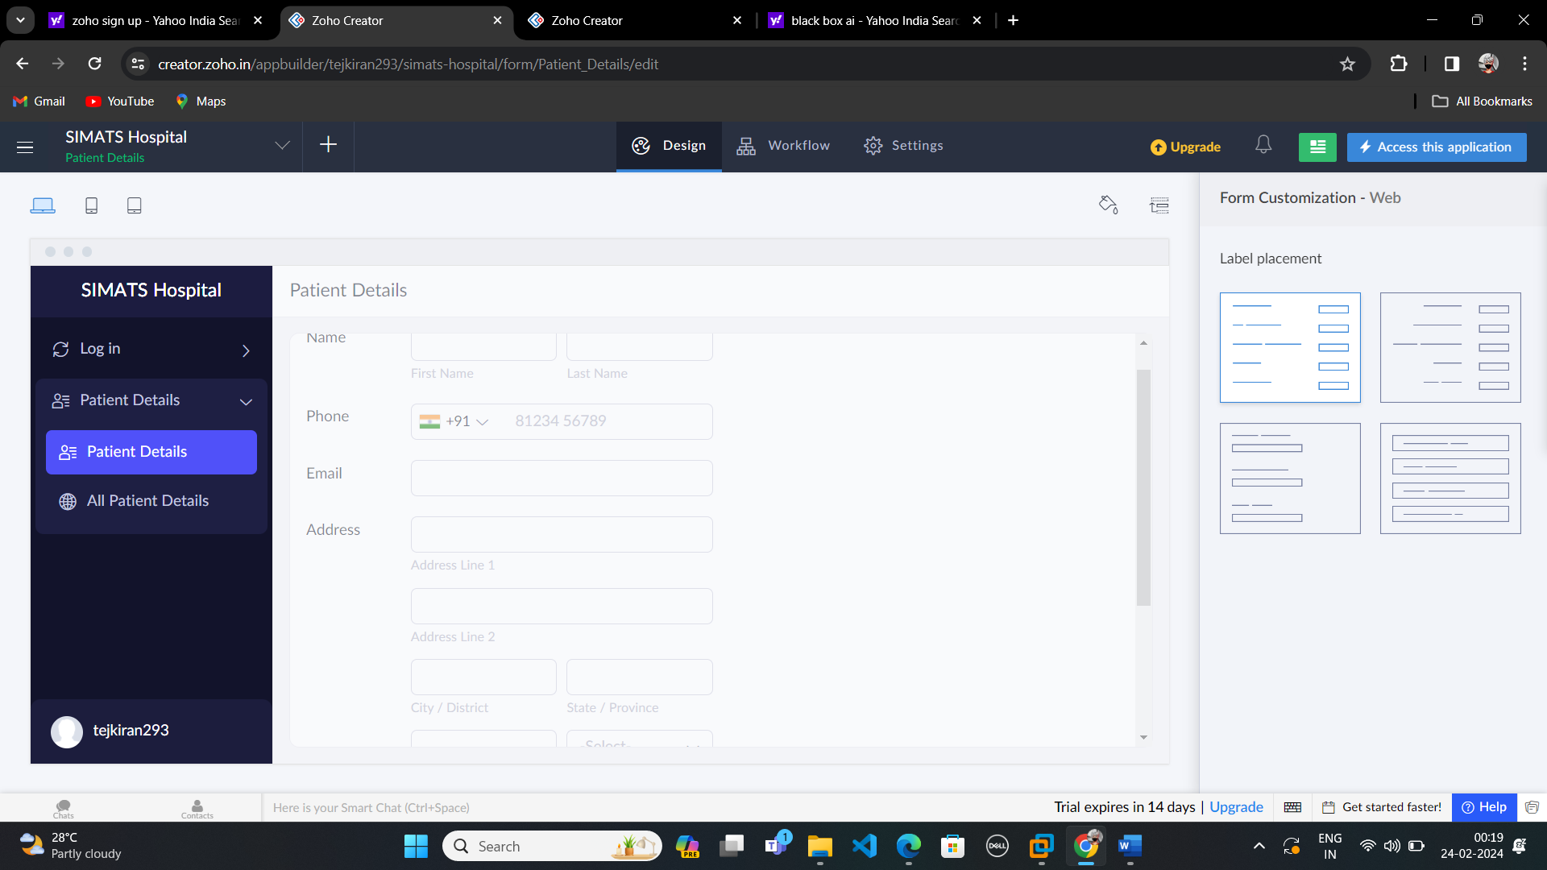

**Step-06:**

After creating that create another form and name it as Medical Details.

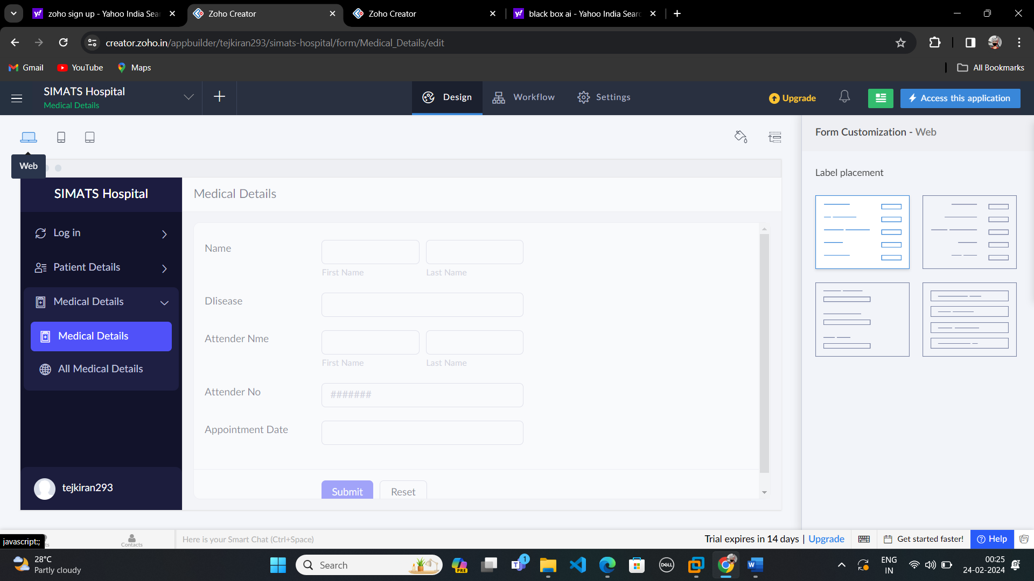

**Step-07:**

Create Payment form

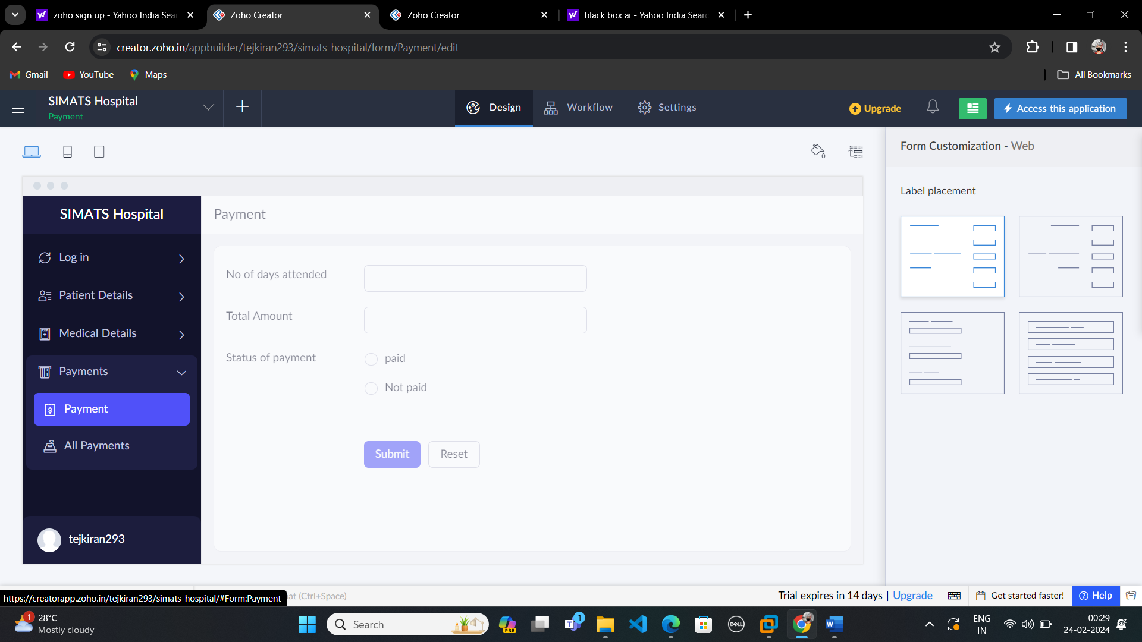

**Step-08:**

After creating Payment form tap Access this Application.

